Introduction to Making Graphical User Interfaces
Using Glade and GTK+ in C++

Preface

In working up to this book, I have learned and taught myself many things about programming. Many of the subjects which will be covered in this book are the product of many hours of YouTube and book reading. I would like to take this opportunity to address the younger programmers reading this book and offer some encouragement to not give up coding. This may seem hard at times but with the right dedication and patience you can push through all the contents of this book. I wrote everything in this book with you in mind. Take advantage of the code examples and dissect them in order to gain some understanding of the creation process. I would also like to take this opportunity to thank my wife and kids for all the love that they give me. Without you I would be nothing. Thank you for being the best family in the world. Some of the examples in this book were designed by my son Daniel E. Vigo who is 5 years old at the time of the writing of this book. Thank you Daniel for all your contributions to this book. I love you son. Stay smart and keep on learning.

Index

Preface ………………………………………………………………. pg.2
Chapter 1 – Introduction …………………………………………….. pg.4

Chapter 1 – Introduction

Welcome to the world of Gnome Tool Kit graphical user interface programming. The Gnome Toolkit was first developed for the GIMP software which is a Linux based advanced image processing software that was written as an open source application for all Linux distributions. The usefulness of the toolkit proved itself so prevalent that the toolkit has survived GIMP and has gone on to become the graphical toolkit that is used to make all the graphical user interfaces for the applications in all Gnome distributions of Linux such as Ubuntu and other popular distributions. GTK is a set of libraries that allow us to create responsive user interfaces using our favorite programming languages. The libraries come with bindings for most of the modern and popular programming languages available today. In this book we will be focusing on GTK+ which is the C/C++ libraries for the GTK toolkit. Throughout the book I will be assuming that you are using a standard Linux distribution running the Gnome desktop. Now if you’re ready to begin this adventure, let’s get all the necessary software installed on our systems and get started.
The very first thing we need to do, is fire up a terminal and install all of the packages we will need to make our interfaces. We will begin by installing GTK+ and Glade using apt-get. So click on the menu icon and type in “Terminal” and click on the terminal icon. When the terminal opens, the very first thing we need to do is update the list of available packages for your system. To do this type the command “sudo apt-get update” and press the enter key. It will look similar to the following image:

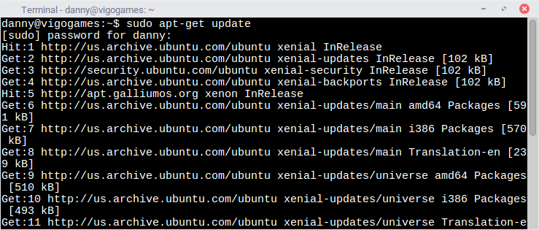
Figure 1-"sudo apt-get update" - update your package manager's list of available packages

Once the list of available packages has been updated, we will update all of our installed packages using the new list to the latest versions available. To do this you will need to issue the following command: “sudo apt-get upgrade”. Once you issue the command it should look similar to the following window. This process might take a while depending on how long it’s been since you upgraded your system packages.

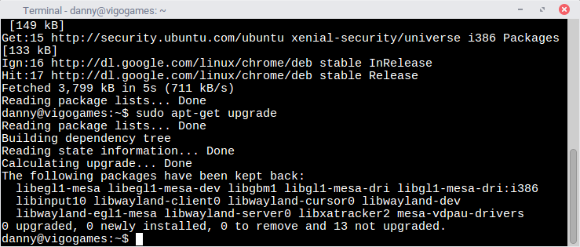
Figure 2-"sudo apt-get upgrade" - upgrade your installed packages to the latest versions

Now that the system has been upgraded to the latest version, we can proceed to install Glade and GTK+ along with all the dependencies which we will need to create our GUI applications. To do this please enter the following commands into the terminal: “sudo apt-get install libgtk-3-0 glade”. This command will install the latest version of the GTK libraries as of the time of writing of this book which is version 3.0. Glade will also be installed. Let me take a moment to explain what Glade is and how we will be using it to create our applications.
Glade is a WYSIWYG(What You See is What You Get) editor used for laying out the GUI separately from the implementation code. Glade also allows us to not only lay out the components but also set up the signals associated with each component. This is particularly helpful because it enables us to link callback functions in our implementation code with actions the users take while interacting with our graphical user interface. The Glade application generates a “.glade” XML file which contains the structure of our GUI along with some additional information about signal callbacks which we then summon from our implementation code. Now that we know what Glade is and what it is used for, lets begin using it to make the famous “Hello World” program. Fire up Glade by typing “glade” into the terminal window and pressing enter. When the program starts up you will see this:
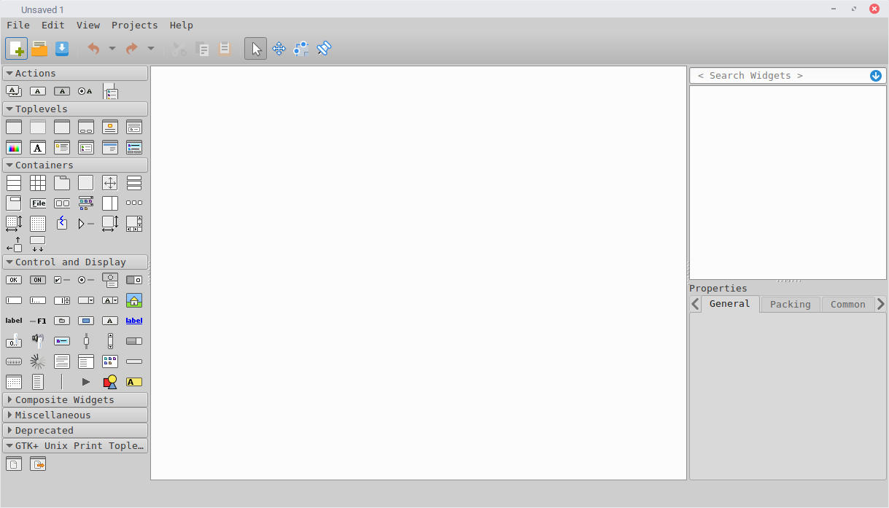
Figure 3-Glade Version 3.18.3
There are two sections that we are most interested with for this simple introduction. The first section is the palette. This is the section that contains all the templates for the different GUI components on the left. This section is separated into several subsections such as “Actions”, “Toplevels”, “Containers”, “Control and Display”, “Composite Widgets” etc. The second section we will focus on will be the Properties section on the bottom right side of the window. This section contains all the properties for the individual components that we assign to our GUI. Here we can change things such as formatting, color, position, size and even assign callback functions for the different signals that our components can emit or receive.

